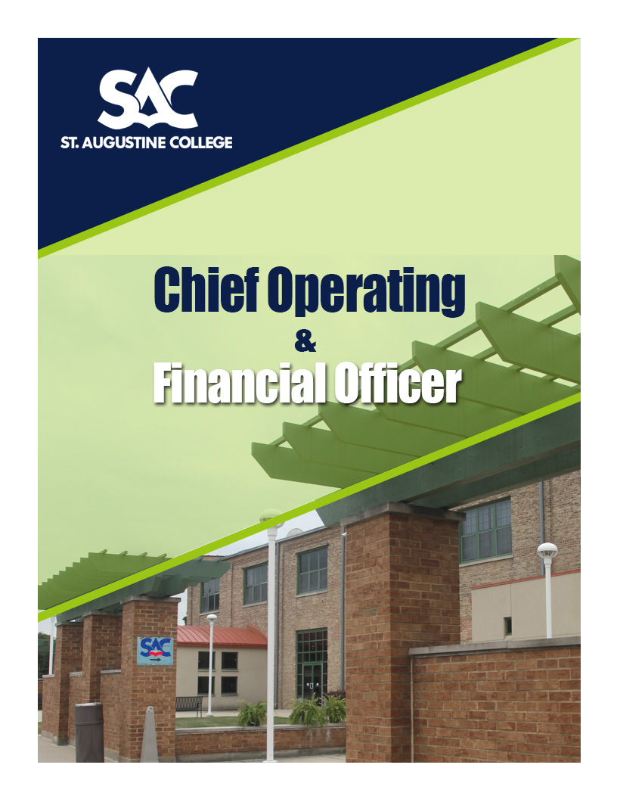

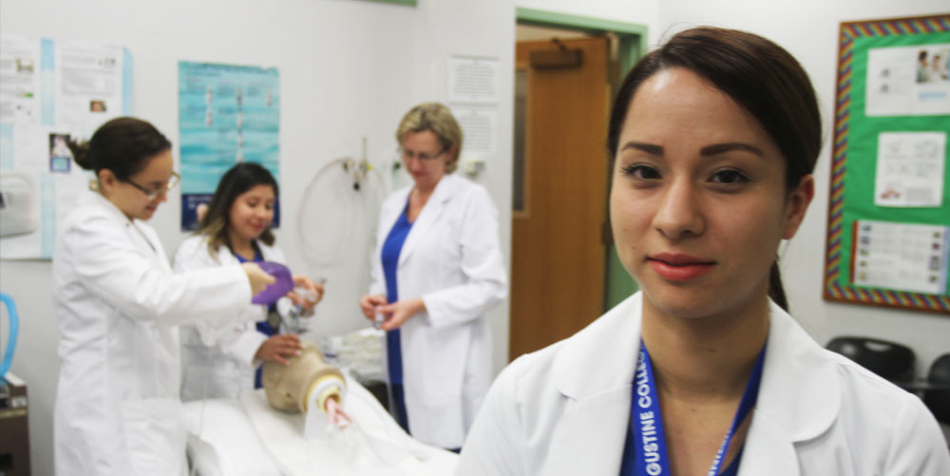

**St. Augustine College**

***A bridge to a better future!***

|  |  |
| --- | --- |
|  |  |
| **ABOUT ST. AUGUSTINE COLLEGE**   * Mission * History * Philosophy * Recent Institutional Highlights * Student Demographics * Memberships * Academic Degree Programs * Institution for Workforce Education * Locations | **Pg. 2** |
| **THE OPPORTUNITY**   * Opportunities and Expectations for Leadership * Personal Qualifications and Qualities * Specific Responsibilities | **Pg. 15** |
| **PROCEDURE FOR CANDIDACY** | **Pg. 20** |

# **ABOUT ST. AUGUSTINE COLLEGE**

St. Augustine College is an independent Latino institution of higher education, dedicated to providing innovative education and workforce development training through a unique, supportive learning environment, making higher education and its benefits accessible to a diverse student population, leading to social and economic mobility. St. Augustine College takes pride in being a mission-driven, student-centered higher education institution which values bilingualism, student success, diversity, inclusion, innovation, intellectual growth, professional development, teamwork, and accountability.

St. Augustine College is accredited by the Higher Learning Commission of the North Central Association of Colleges and Schools (NCA) and is a founding member of the Hispanic Association of Colleges and Universities (HACU). The college has four sites in the Chicago area communities of Little Village, Humboldt Park, Southeast Chicago, and Uptown. A fifth site is located in Aurora, Illinois. The workforce development arm of the institution initiated programming in Waukegan, Illinois in 2017.

**MISSION**

St. Augustine College is an independent, bilingual (dual-language) institution of higher education created under the auspices of the Episcopal Diocese to make the American system of higher education accessible to a diverse student population with emphasis on those of Hispanic/Latino descent; to strengthen ethnic identity; to reinforce cultural interaction; and to build a bridge to fill cultural, educational, and socio-economic gaps.

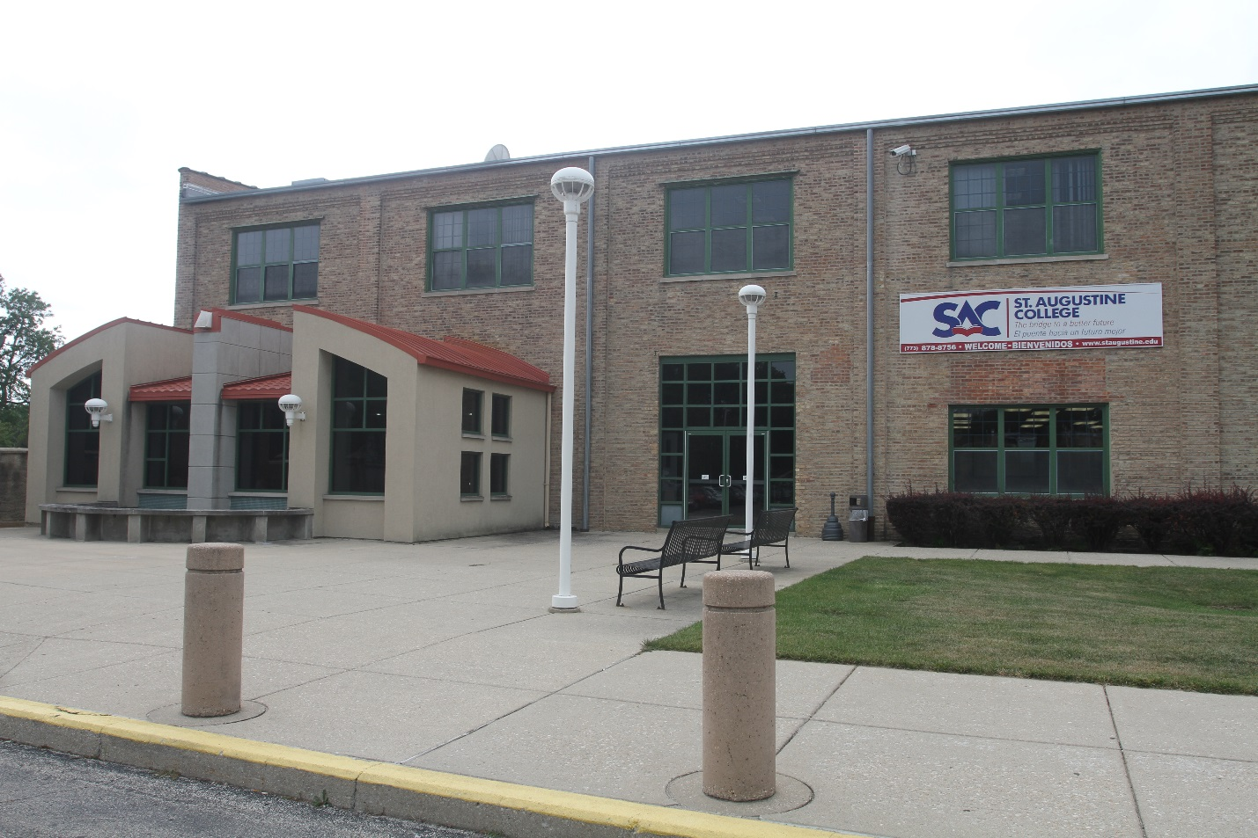

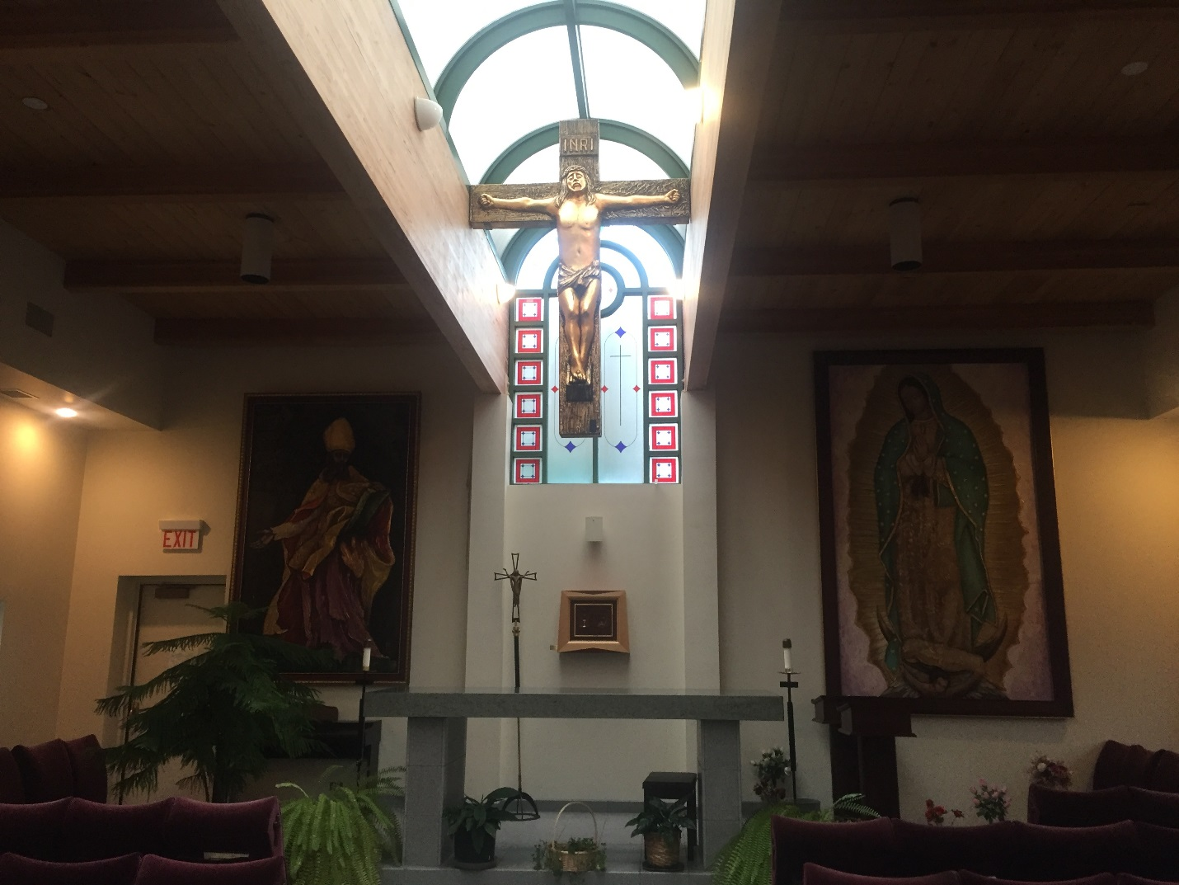

**HISTORY**

On October 7, 1980, the Illinois State Board of Higher Education granted operating authority to the first bilingual institution of higher education in Illinois: St. Augustine College. This educational setting is unique in Illinois, and one of a few in the country. It came into existence as a result of years of work, observation, and research, and is based on more than ten years of community work performed by the Spanish Episcopal Services, an educational agency that was created under the auspices of the Episcopal Diocese of Chicago by Father Carlos A. Plazas, Ph. D., in 1970.

The St. Augustine College founders reacted to observation and research that indicated that a large number of Hispanic/Latino adults, because of specific circumstances, could avail themselves of dual-language (bilingual) academic and vocational career training. These findings also indicated that many Hispanic/Latino adults were capable of actively participating in four-year degree programs, but needed educational assistance to be able to compete at this level of education. Since there were no institutions of higher education to respond to these educational needs and provide opportunities for dual-language learning, the Board of Directors of Spanish Episcopal Services elected to support the formation of St. Augustine College.

**PHILOSOPHY**

* We believe that being bilingual is an asset for the individual as well as for our multicultural society.
* We believe that excellence in bilingual education includes mastery of the English language, and we are committed to providing our students with ample opportunities to learn it well.
* We believe that a diverse student population can become academic achievers when bilingual teaching and learning methods are made available to them.
* We believe that the cultural sensitivity of our staff and faculty are instrumental in the development of our students.
* We believe that the interchange of dual language and cultural experiences adds significant value to our students’ education and their worth to society.
* We believe that our faculty has the ability to help educationally disadvantaged students reach a level such that they are prepared to function effectively in American society.
* We believe that education is a lifelong endeavor and, therefore, encourage people to return to school at any age for self-development and for the benefit of those they serve.
* We believe in a nurturing environment for our students, faculty, staff, volunteers, and benefactors.



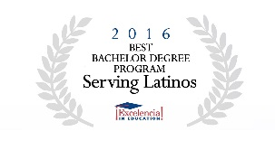

**RECENT RECOGNITION**

* Latino Leaders national magazine recently named St. Augustine College one of the best Colleges for Latinos in the country.
* The St. Augustine College Respiratory Therapy Program surpasses the national average when it comes to its students passing rate for the Illinois state licensing exam.
* The St. Augustine College Social Work Program was recognized by Excelencia in Education for being the only Bachelors in Social Work program of its kind in a Midwest college with a bilingual curriculum.
* 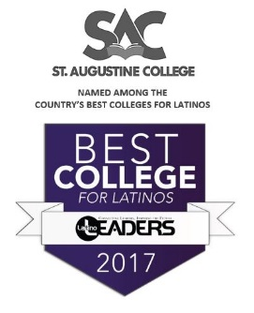According to the study “Highest Upward Mobility Rate Colleges” conducted by The Equality of Opportunity Project and published by the New York Times, St. Augustine College was ranked 1st of non-selective school in the state, 4th in the country, for raising the socioeconomic status of its graduates.
* St. Augustine College is among, if not the largest provider in the Midwest of bilingual entry-level professionals for the field of Early Childhood Education.
* The St. Augustine College Institute for Workforce Education is the largest College-based workforce education program in the state of Illinois.

**STUDENT DEMOGRAPHICS**

More than 85% of St. Augustine College students are Latino.  St. Augustine College works with students who are traditionally outside the system. They have the most challenges in achieving higher education. Therefore, St. Augustine College has open enrollment.  As long as students are able to demonstrate that they obtained a high school diploma or equivalent in the United States or abroad, the student is welcomed into our College.

The majority of our students, 87%, qualify for a Pell Grant and 65% qualify for both the Federal Pell Grant and Illinois Monetary Award Program. In the 2016-2017 academic years, St. Augustine College awarded $5.2 million and more than 1200 scholarships to students to cover the gap between government grants and tuition costs.

If Spanish is the student’s primary language, it is not a barrier at St. Augustine College. Students may begin their courses in Spanish and transition to courses in English as they progress in their academic career. Furthermore, the Writing Across the Curriculum initiative supports English language development while the student is taking college courses.

The St. Augustine College graduation rate is at 39%, which is above the national average for open admissions institutions and above that of comparable area higher education institutions. Furthermore, compare this rate to the fact that only 21% of Latinos in Illinois have earned and associate degree or higher.





**STUDENT FACTS**

|  |  |
| --- | --- |
| * Enrollment: 1203 * Gender:   + 79% Female 21% Male * Ethnicity:   + 87% Hispanic/Latino   + 2% Asian   + 2% African American   + 1% Caucasian   + 8% Other | * 92% of students are between the ages of 18-49 * 93% of students own a smartphone * 67% of students like the flexible schedule * 43% of students attend because of bilingual courses |

**COLLEGE MEMBERSHIPS**

* Colleges and Universities of Anglican Communion (CUAC)
* Council for Higher Education Accreditation (CHEA)
* The Federation of Independent Illinois Colleges and Universities (FIICU)
* Illinois Latino Council on Higher Education (ILACHE)
* Hispanic Association of Colleges & Universities (HACU)
* National Association of Independent Colleges and Universities (NAICU)
* Aurora Education and Workforce Commission
* Yes We Must Coalition

**ACADEMIC DEGREE PROGRAMS**

<http://www.staugustine.edu/academics/academic-programs/>

St. Augustine College’s Academic Programs prepare students for upwardly mobile professional careers. The institution currently has five bachelor degrees. The first and most established bachelor program is the Bachelor of Social Work. During the last few years, the College added a Bachelor of Arts in Psychology, and a Bachelor of Arts in Hospitality Management, and, most recently, the College was accredited to provide a Bachelor of Science in Computer Information Systems and a Bachelor of Arts in Business Administration. In addition, the College has numerous successful associate degree programs, including Early Childhood Education, Respiratory Therapy, and Culinary Arts, that create a pathway to the bachelor degree programs.

St. Augustine College is accredited to provide the following programs:

**Department of Social Work**

* Bachelor of Social Work (BSW)

**Department of Business, CIS, and Culinary Arts**

* Business Administration (BA)
* Business Administration (AA)
* Accounting (AAS)
* Business Management (AAS)
* Administrative Assistant (AAS)
* Computer Information Systems (BS)
* Computer Information Systems (AAS)
* Culinary Arts (AAS)
* Hospitality Management (BA)

**Department of Languages, Literature, and Humanities**

* English as a Second Language Program
* Academic English Program

**Department of Early Childhood Education and Social Sciences**

* Early Childhood Education (AAS)
* Psychology (BA)

**Department of Sciences and Health**

* Respiratory Therapy (AAS)
* Academic Math Program



RECENT DEGREE PROGRAM ADDITIONS

In December 2017, The Institutional Actions Council of the Higher Learning Commission approved the St. Augustine College requests to offer the Bachelor of Arts in Business Administration, and the Bachelor of Science in Computer Information Systems. Course offerings began in January 2018. The new degrees join the three existing Bachelor’s Degrees that St. Augustine College has been offering: Social Work, Psychology, and Hospitality Management. An application to offer a Bachelor of Arts in Early Childhood Education is in progress.

**INSTITUTE FOR WORKFORCE EDUCATION**

<http://www.iwetraining.com>

The Institute for Workforce Education (IWE) is the leading provider of dual language workforce development services in Illinois. IWE programs add value to businesses, organizations, and professionals through the delivery of results-driven, customized training services. IWE works with more than 2,000 students annually and is the largest college-based workforce development program in Illinois.

**Workforce Solutions**

Workforce Solutions provides custom needs assessment, including curriculum and instructional design, in-depth training, evaluation and reporting, through a cohesive and comprehensive approach. Workforce Solutions includes WorkFitTM to evaluate client training needs, market trends, and funding opportunity to develop custom workforce programs that get funded. Student Credentialing assesses current program participants and provides them with St. Augustine College workforce credentials to make them competitive in today’s environment. Train-the-Trainer empowers teams to lead a classroom using adult education techniques effectively.

**Professional Development**

The School of Professional Development (SPD) provides high-quality workforce training that gives students the competitive edge they need to take their career to the next level. SPD utilizes market-relevant curriculum delivered by trainers with real-world experience.

**Adult Education Unit**

The Adult Education Program provides GED Preparation courses and Pre-GED instruction. Programs are offered at each of St. Augustine College sites.

**Career and Transfer Center**

The Institute for Workforce Education manages St. Augustine College’s student Career and Transfer Center (CTC). The CTC staff prepares students for employment by assessing their interests, personalities, values, and by discussing best career options for the student. Staff members assist students and alumni with resumes, networking, mock interviews, job leads and job placements. The CTC has successful working relationships with an array of employers from a variety of related fields to facilitate work experiences and internships for students within their chosen career field. For students seeking to advance their academic career beyond St. Augustine College, the Career and Transfer Center helps students complete and submit admission applications to four-year institutions.



# **LOCATIONS**

St. Augustine College hosts programs in the cities of Chicago and Aurora. The Institute for Workforce Education additionally offers training in Waukegan.

**CHICAGO, IL**

Chicago, on Lake Michigan in northeast Illinois’ Cook County, is the third largest city in the U.S. The 2016 estimated population of 2.7 million makes Chicago the third largest city in the United States, behind New York City (8.55 million) and Los Angeles (3.97 million). Chicago is by far the largest city in Illinois, with the next largest city, Aurora, being under 200,000 people.

Chicago has the fifth highest foreign-born population in the United States. The racial makeup of the city in 2010 was 45.3% Caucasian (31.7% non-Hispanic/white), 32% African American, 5% Asian, and 3% from two or more races. The ethnic makeup of the population is 28% Hispanic/Latino, and 72% belong to non-Hispanic backgrounds. In 2000, 21.7% of the population was foreign born; of this, 56.3% came from Latin America, 23.1% from Europe, 18.0% from Asia and 2.6% from other parts of the world.

In 2016, the population of Hispanics/Latinos exceeded that of African Americans to become Chicago's second largest minority group with non-Hispanic/white representing 32.6% of the population, Hispanic/Latino at 29.7% of the population, and African Americans at 29.3% of the population.

The College has four sites in the following Chicago communities: Little Village, Humboldt Park, Southeast Chicago, and Uptown.



**AURORA, IL**

Aurora, “The City of Lights”, is the second largest city in Illinois. It is west of Chicago, predominantly located in Kane County and DuPage County, with portions extending into Kendall and Will counties.

Aurora has the racial makeup of 42% Hispanic/Latino, 38% Caucasian, 9% African American, and 7% Asian according to the most recent Census. The City of Aurora is in a stage of growth and development, and has a shortage of culturally and linguistically relevant programming and services.

St. Augustine College purchased a facility and opened a site on the northern side of the City of Aurora in 2014. Program offerings include academic degrees and workforce development programs. It is the site with the most growth in student enrollment and is uniquely positioned to continue its growth.



**WAUKEGAN, IL**

Waukegan is the ninth-largest city in Illinois by population, and it is the fifth-largest city on the western shore of Lake Michigan, after Chicago, Milwaukee, Green Bay, and Kenosha.

As of the 2010 United States Census, 89,078 people were residing in the city. Of the population, 53.4% were Hispanic/Latino (of any race), 46.6% were Caucasian (21.7% non-Hispanic/White), 19.2% Black or African American, 4.3% Asian, 1.2% Native American, 0.1% Pacific Islander, 24.6% of some other race and 4.1% of two or more races.

St. Augustine College’s Institute for Workforce Education offers GED Preparation courses and Pre-GED instruction at the site of a community partner in Waukegan.



**OPPORTUNITY DESCRIPTION**

With continued growth in the Latino population and in higher education, St. Augustine College is at a very exciting juncture in its history. As a key member of the President's senior leadership team, the **Chief Operating & Financial Officer** serves as a strategic partner and adviser to the President, senior leadership team, and the Board of Trustees on all matters related to the business and financial planning for the institution.

St. Augustine College is searching for an innovative leader with financial and operations acumen to assist the president and the college community in transforming the college into a university of the future. The Chief Operating & Financial Officerwill be involved in almost every facet of the institution, including enrollment, financial aid modeling, academic program development, fundraising, student retention, IT, Human Resources, campus security, and facility operations.

The successful candidate will have an opportunity to develop financial forecasting models, the business model for the university of the future, and for each department and program. The candidate will perform root-cause-analysis, risk analysis and implement an institutional risk management program. The College is moving towards becoming a national university.

The Chief Operating & Financial Officerwill collaborate with the president and senior leaders to chart the vision for the next decade and beyond, and will play a critical and on-going role to bring that vision to reality. The Chief Operating & Financial Officerwill assist the president with vision, strategy development, partnerships, fundraising, and the creating of big ideas for modern, forward-thinking solutions.

The Chief Operating & Financial Officerwill develop effective and innovative, state-of-the-art processes and analytical systems that will lead the institution toward a higher organizational performance. She/he will establish the appropriate data analytics and provide appropriate and timely information for the institution to make fact-based decisions, and promote excellence, innovation, and continuous improvement.

The Chief Operating & Financial Officeris the chief financial, business and administrative officer of the College who sets the financial agenda for the insititution, and provides guidance and leadership to ensure the efficient, effective, and timely stewardship of the College's financial resources and operations, including development and administration of financial policies and procedures; accounting; external auditing; accounts payable and receivable; insurance programs; benefits plans; operating and capital budgets; management over the College’s relationships with lenders; and various third party relationships.

This position oversees all finance functions including budgeting, accounting, financial reporting, long-range financial planning, treasury management, investments, asset management, liability management, and risk management. She/he is also responsible for other non-finance functions including the operation and maintenance of facilities, purchasing, contracts, and auxiliary services.

The Chief Operating & Financial Officerleads St. Augustine College's short- and long-term financial and capital planning, ensuring that resources are deployed efficiently and in support of the College’s mission.

The Chief Operating & Financial Officerplays an active role in shaping the strategy and a culture of excellence and innovation. As a key institutional leader, the Chief Operating & Financial Officeris a big-picture thinker, with outstanding skills in analytics and attention to detail, who will bring counsel, collaboration, and ensure the integrity of fiscal data and modeling transparency and accountability.

The Chief Operating & Financial Officerleads and engages the finance and administrative teams in information technology, human resources, facilities and auxiliary services to ensure fiscal integrity, the effective management of financial resources, and the deployment of resources in support of the College’s mission.

The Chief Operating & Financial Officerserves as a business partner to other members of senior management including the Board, and the Audit & Finance committee, providing insight and counsel relative to all areas of strategic planning, growth and financial leadership. She/he will help lead the University of the Future confidently by providing assurance, and by strengthening governance, risk management, and compliance functions.

The Chief Operating & Financial Officerembraces a culture of respect for the individual, integrity, ethics and transparency, and has the ability to set a standard for their leadership to follow.

The Chief Operating & Financial Officerensures organization-wide compliance with all FASB, GAAP, and federal, state and other regulatory requirements, and government reporting, Sarbanes-Oxley and SEC requirements.

The Chief Operating & Financial Officerensures a high-performance finance team, will have a passion for developing and mentoring people, and embed best practices, including organization-wide continuous improvement.

In short, the Chief Operating & Financial Officer will have an opportunity to help shape an innovative, state-of-the-art institution. If you are a creative leader and builder, who drives towards excellence, this opportunity is for you.

**KEY RELATIONSHIPS**

Reports to the President and Board of Trustees. Direct reports include but are not limited to: Bursar’s Office, Director of IT, Director of Human Resources, and future directors of Facility Management, Auxiliary Services, and Controller’s Office.

**REQUIREMENTS**

* Significant broad senior-level management experience, providing strategic financial and operational leadership, preferably in higher education;
* Undergraduate degree in accounting, finance, business administration, or equivalent business experience; Financial Certification or Master’s degree in business, accounting or closely related discipline is required.
* Experience in partnering with an executive team.
* Demonstrated expertise in strategic financial planning, investment management, debt financing and management;
* Strong working knowledge of financial and information technologies;
* Proven ability to handle a broad set of responsibilities;
* Commitment to personal and professional integrity; and the ability and desire to support the College’s mission.
* A strong strategic orientation with the ability to effectively partner with, and communicate to, the President and other leaders on the senior administrative team.
* Experience recruiting, developing, and retaining a high-performing team;
* Strong analytical acumen and technical capability, and the ability to translate technical information into usable and understandable format.
* Proven track record in implementing innovative processes and systems.
* Experience in leading each of the areas under her/his responsibility.
* Proven track record as a change agent committed to excellence.

**OPPORTUNITIES AND EXPECTATIONS FOR LEADERSHIP**

Among the many opportunities the President and President’s Cabinet will be asked to address are the following critical leadership issues:

**Lead a Mission-Centered College**

Since its founding in 1980, St. Augustine College has been committed to its mission of providing exemplary education and professional entry opportunities to a bilingual, bicultural student body, and the values of equal opportunity, social justice, and support for student aspirations. The College values educating students to enter career fields of their choice with the education, skills, and abilities to succeed and prosper in their work lives.

**Provide Collaborative Leadership to Achieve Shared Goals**

The College seeks leaders who are effective communicators and who lead through collaboration and shared governance. Members of the faculty and administration at St. Augustine College are eager to play an active and responsible role in the overall governance of the College. Our leaders must have unquestioned integrity, maturity, sound judgment, and an impeccable reputation. Our leaders will devote time with administrators, faculty, students, and alumni, to bring further cohesion to an institution that is planning for an even more ambitious array of programs and services as part of its sustainability plans. The President and members of the President’s Cabinet will foster an agile team-oriented environment that will support the effective communication of goals and objectives and will provide the tools to help the entire community grow and develop collectively and individually.

**Grow Enrollment and Retention**

The President recognizes that it is paramount to establish an institution of the right size with the right resources to be sustainable. This will require that enrollment be increased in the right areas and that the leadership team be charged with envisioning the optimal enrollment strategy for the College. The entire leadership team will be required to participate in the development of a comprehensive, multiyear plan for the structure, programs, initiatives, and resources required to succeed with such a plan. Assessment of the needs and aspirations of the satellite campuses will be important in the strategic discussion of enrollment opportunities for the College.

**Increase Philanthropic Support/Raise Brand Awareness**

The College is committed to prioritizing fundraising from many sources. A reinvigorated, institution-wide commitment to raising the College’s profile through marketing and externally focused activity is a key commitment for leaders at the College. Expanding the solicitation of major gifts, external grants, and annual fund support will be critical to success. The leadership team will foster a culture of philanthropy and oversee the work of a development team which is results-driven and committed to the long-term stability, expansion, and success of the College.

**PERSONAL QUALIFICATIONS AND QUALITIES**

St. Augustine College’s leaders will join a committed and dedicated community and bring vision, passion, and the ability to execute an ambitious plan for the College. The College expects its leaders to share the commitment to providing educational opportunities to persons from underserved communities, with a particular emphasis on the Hispanic/Latino community, and will demonstrate the desire and commitment to work within a diverse and dynamic community.

The College is working to build its infrastructure and improve systems throughout all aspects of the organization. The College expects its leaders to value, respect, and work easily within a College that is in pursuit of enhancing its data collection and analytics to both optimize student success and achieve institutional effectiveness. In an increasingly competive higher education environment, the Vice President is expected to have a data-driven mindset to penetrate all levels of decision making, from program development to student retention and graduation.

The ideal candidate shall be outcomes-driven, a visionary, and collaborative; focused on excellence, inspiring passion, and driven by the implementation of creative systems and processes for success.



**EXPECTATIONS AND BENEFITS**

This position will be based out of St. Augustine’s main campus in Chicago. The position is full-time.

The COO/CFO will be eligible for St. Augustine’s standard benefit offerings, commensurate with the benefits offered to similar executive level employees.

**PROCEDURE FOR CANDIDACY**

# **INQUIRIES, NOMINATIONS AND APPLICATIONS**

Review of candidate materials will begin immediately and will continue until the position is filled.

For fullest consideration. please provide the following information:

1. **Resume or Curriculum Vitae**
2. **A letter of application that addresses the responsibilities and requirements described in this leadership profile**
3. **Names and contact information for five references. References will not be contacted without prior approval by candidates.**

**For a confidential discussion of this position prior to applying or nomination, contact, Nancy Ocampo at** [**nocampo@staugustine.edu**](mailto:nocampo@staugustine.edu)

**Phone Inquiries: 773-878-6335**

**Requested materials should be sent via e-mail to** [**nocampo@staugustine.edu**](mailto:nocampo@staugustine.edu)

St. Augustine College values diversity and is committed to equal opportunity for all persons regardless of age, color, disability, ethnicity, marital status, national origin, race, religion, sex, sexual orientation, veteran status or any other status protected by law.

All images and logos used in this leadership profile were attained from St. Augustine College.